

Dear Parents and Guardians,

Welcome to the Jordan Bank Library-Media Center. This year your children will be working with myself,

Mrs. Kim Lewin, Library-Media Specialist and a library clerk. I welcome you to volunteer and assist us with our many library duties.

Students will be checking out books from the library-media center to bring home. Please help us reinforce personal responsibility in our children by assisting them in taking care of their library books by:

* Finding a safe place to keep their books, away from younger children, pets, food, and drinks
* Returning their library books on time and renewing them if necessary
* Returning overdue library books and/or paying for any damaged or lost library books

Our book circulation policy is as follows:

* Students will check out one library book during designated library hours during the first half of the school year
* Once independent reading levels have been established, students will have the opportunity to check out two library books.

We look forward to working with each family this year. Please sign and return the following portion of this page to acknowledge your role in the success of our library-media program at Jordan-Bank.

Sincerely,

Mrs. Lewin

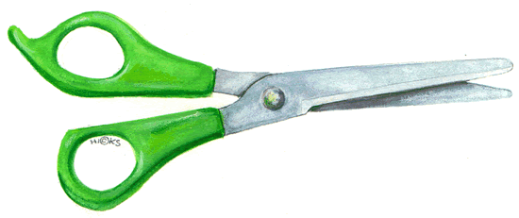

My student,

________________________________________________________, has read and agreed to the library-media procedures and regulations for book circulation.

________________ _________________________________

DATE Parent or Guardian Signature

__________________________________

Teacher Name

